

Practices for Secure Software Report

Table of Contents
Document Revision History 3
Client 3
Instructions 3
Developer 4
1. Algorithm Cipher 4
2. Certificate Generation 4
3. Deploy Cipher 4
4. Secure Communications 4
5. Secondary Testing 4
6. Functional Testing 4
7. Summary 4
8. Industry Standard Best Practices 4

Document Revision History

Version | Date | Author | Comments
1.0 | 4/19/2026 | Thomas Tran | Professor Kevin Matthe Caramancion

Client



Instructions

Submit this completed practices for secure software report. Replace the bracketed text with the relevant information. You must document your process for writing secure communications and refactoring code that complies with software security testing protocols.

- Respond to the steps outlined below and include your findings.
- Respond using your own words. You may also choose to include images or supporting materials. If you include them, make certain to insert them in all the relevant locations in the document.
- Refer to the Project Two Guidelines and Rubric for more detailed instructions about each section of the template.

Developer
Thomas Tran
SNHU CS305-17406-M01: Software Security

Algorithm Cipher

For this project, the recommended encryption approach is to use AES-256 along with the SHA-256 hashing algorithm. First, AES is a symmetric encryption method, meaning the same key is used for both encryption and decryption, and it is widely used because it provides strong security. The 256-bit key makes it very difficult for attackers to break. Second, SHA-256 is a hashing algorithm that creates a fixed output used to verify data integrity. Since hashing is a one-way process, the original data cannot be reversed, making it useful for ensuring data has not been changed.

By using AES-256 and SHA-256 together, it helps protect sensitive financial data by ensuring both security and data integrity. This is a recommended choice for Artemis Financial, as it mainly works with large financial data, meaning that they require a strong and secure encryption method to protect data security.

Certificate Generation

Fo the project, I create a self-signed certificate was generated using the Java Keytool utility within the Eclipse IDE. The certificate was created using RSA with a 2048-bit key and stored in a PKCS12 keystore file. The certificate was then exported as a CER file for verification and documentation. The Keystore is then added to the project as shown below.

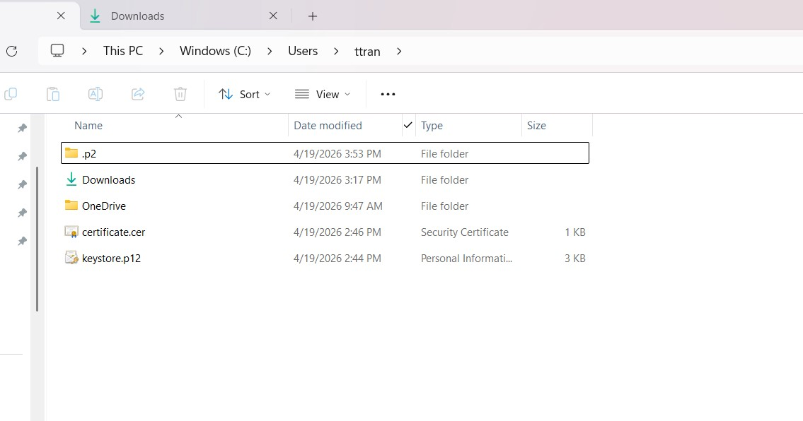
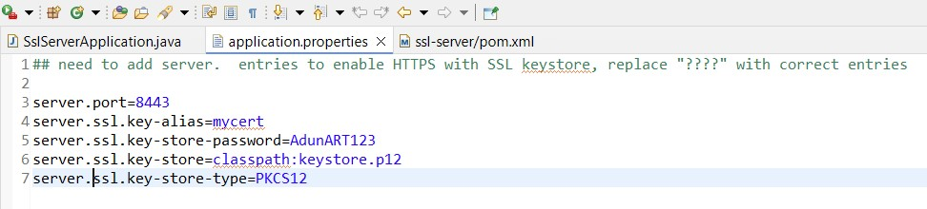

Deploy Cipher

The application was modified to include a SHA-256 hashing function to generate a checksum for a unique data string. This checksum ensures that the data has not been altered and maintains data integrity. The “/hash” endpoint was created to display both the original data and the generated checksum. I run the check-sum verification and capture the result.

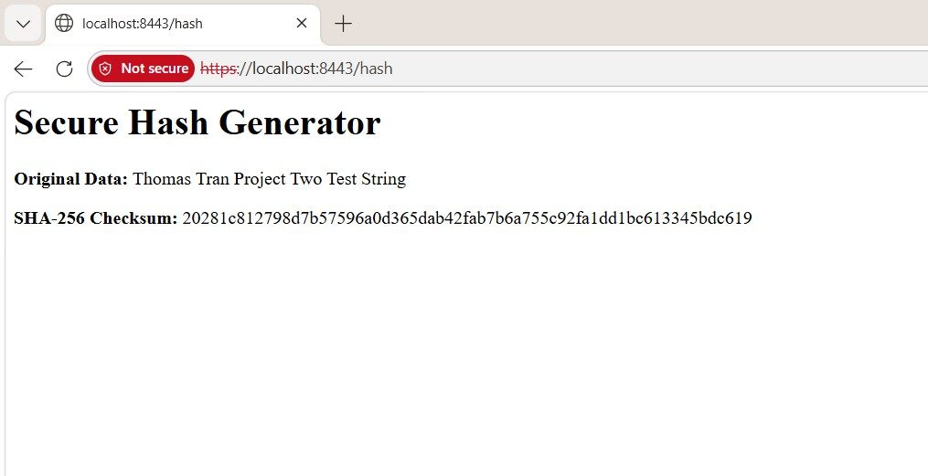

Secure Communications

I implemented secure communications goal by configuring the application to use HTTPS instead of HTTP. This was achieved by adding SSL properties in the application.properties file and linking the keystore file. The application was successfully accessed through a secure HTTPS connection. The screenshot display of The “Not Secure” message appears because a self-signed certificate is used, which is expected during development.

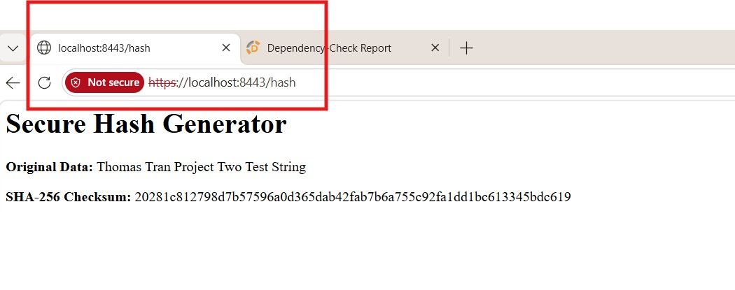

Secondary Testing

A secondary static analysis was performed using the OWASP Dependency-Check tool to evaluate the security of the application’s dependencies. The dependency-check plugin was updated to version 12.1.0 to ensure compatibility with the latest National Vulnerability Database (NVD) updates and to resolve issues encountered during the initial scan. Due to my Eclipse IDE not being able to run the version already included in the codebase. After update, the application executed successfully without errors, as confirmed by the console output. The dependency-check scan completed and generated a report identifying potential vulnerabilities within third-party libraries. These findings are expected when using external dependencies. No new vulnerabilities were introduced by the refactored code. This confirms that the application was successfully analyzed using an updated industry-standard security tool.

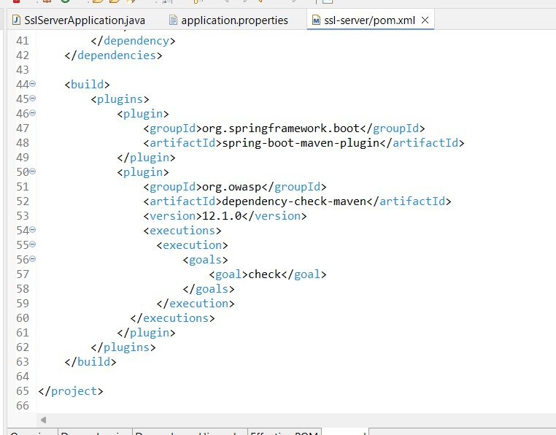
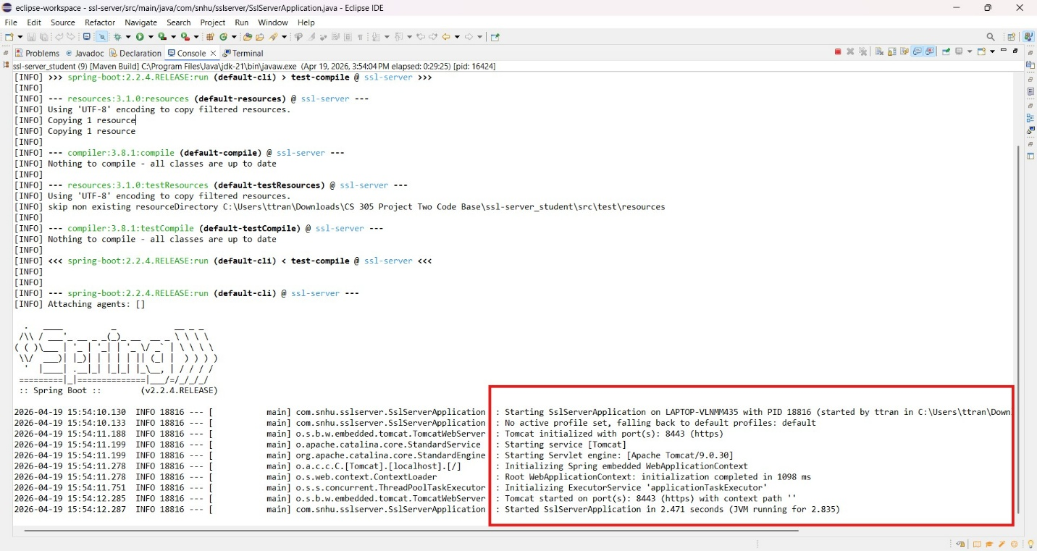
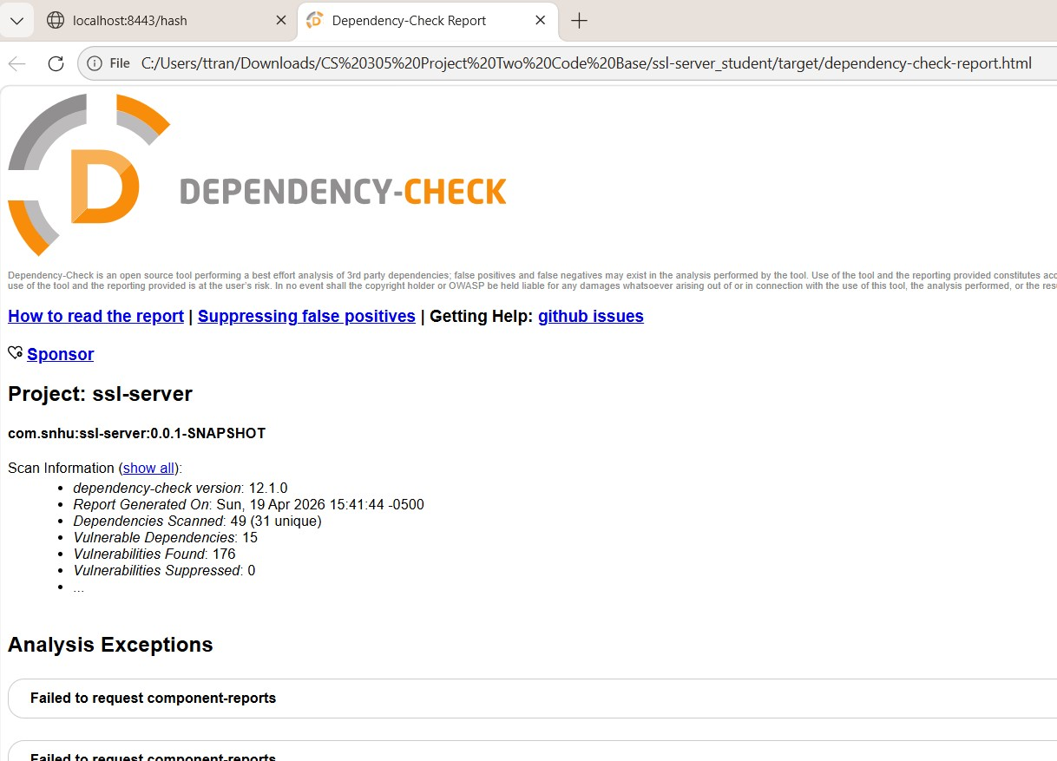
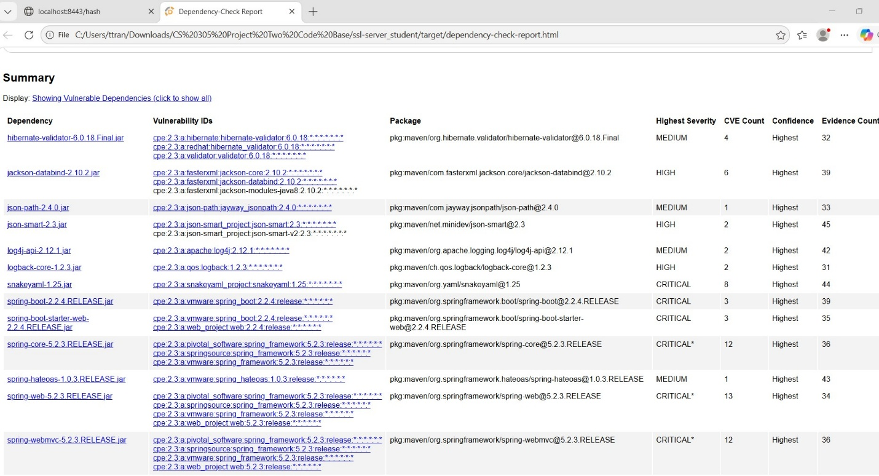

Functional Testing

For the functional testing, I check and verify by running the application in Eclipse and verifying that it started successfully without errors. The console output confirmed that the server was running on port 8443 using HTTPS. The /hash endpoint was tested in a web browser and produced the expected SHA-256 checksum output. This confirms that the application functions correctly and meets the required security enhancements.

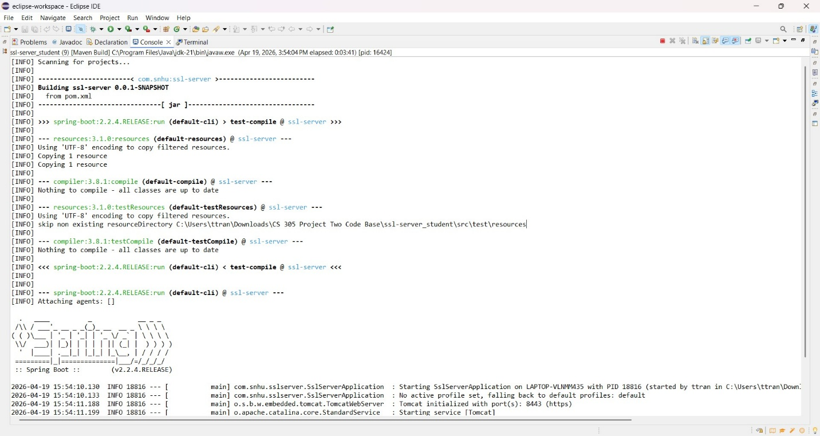


Summary

After running through the checkpoints, the application was successfully updated with improved security. I have implemented encryption-related features, checksum verification, and secure communication using HTTPS. The SHA-256 hashing algorithm ensures data integrity, while HTTPS protects data during transmission.
The process involved generating a certificate, configuring secure communication, and implementing hashing functionality. These changes align with the vulnerability assessment process by addressing security risks related to data transmission and integrity.
By adding multiple layers of security, the application is now more secure and better equipped to protect sensitive financial data from potential threats.

Industry Standard Best Practices

For Artemis Financial, the industry standard best practices were applied to their new software. This was done by using strong encryption methods like AES-256 and SHA-256, enabling HTTPS for secure communication, and running vulnerability scans with dependency-check. These steps help improve the overall security of the application and reduce the risk of cyberattacks. All security updates and dependencies check are recommended to run regularly on a frequent schedule, to ensure everything is up to date.

Using secure coding practices also helps ensure the application runs safely and protects sensitive information. These best practices are important because they help build customer trust, prevent data breaches, and keep the system reliable.

Use of Generative AI
Generative AI tools were used to assist with understanding concepts, improving clarity, and refining the wording of this report. All technical work, code implementation, testing, and screenshots were completed by the student. The final content reflects the student’s own understanding of the assignment requirements.

